29th Sunday in Ordinary Time.
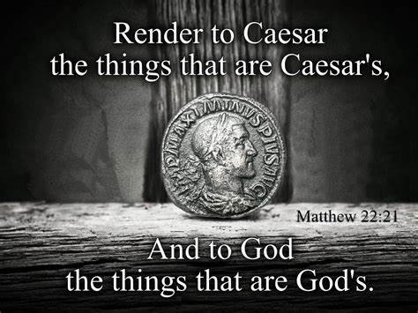

1st Reading: Isaiah 45:1, 4-6
Providence appointed king Cyrus to liberate Israel from the exile in Babylon
Thus says the Lord to his anointed, to Cyrus, whose right hand I have grasped to subdue nations before him and strip kings of their robes, to open doors before him, and the gates shall not be closed:
“For the sake of my servant Jacob, and Israel my chosen,
I call you by your name, I surname you, though you do not know me.
I am the Lord, and there is no other; besides me there is no god.
I arm you, though you do not know me,
so that they may know, from the rising of the sun and from the west,
that there is no one besides me.
I am the Lord, and there is no other.”
Responsorial: Psalm 95:1, 3-5, 7-10
Response: Give the Lord glory and honour
O sing a new song to the Lord,
sing to the Lord all the earth.
Tell among the nations his glory
and his wonders among all the peoples. Resp:
The Lord is great and worthy of praise,
to be feared above all gods;
the gods of the heathens are naught.
It was the Lord who made the heavens. Resp:
Give the Lord, you families of peoples,
give the Lord glory and power,
give the Lord the glory of his name.
Bring an offering and enter his courts. Resp:
Worship the Lord in his temple,
O earth, tremble before him.
Proclaim to the nations: ‘God is king,’
He will judge the peoples in fairness. Resp:
2nd Reading: 1 Thessalonians 1:1-5
St Paul assures his readers that he prays for them and is glad for their zeal as converts
Paul, Silvanus, and Timothy, To the church of the Thessalonians in God the Father and the Lord Jesus Christ: Grace to you and peace. We always give thanks to God for all of you and mention you in our prayers, constantly remembering before our God and Father your work of faith and labour of love and steadfastness of hope in our Lord Jesus Christ.
For we know, brothers and sisters beloved by God, that he has chosen you, because our message of the gospel came to you not in word only, but also in power and in the Holy Spirit and with full conviction; just as you know what kind of persons we proved to be among you for your sake.
Gospel Acclamation:
Alleluia, Alleluia!
Shine on the world like bright stars;
you are offering it the word of life.
Alleluia!

Gospel: Matthew 22:15-21
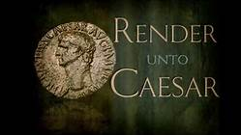

Jesus refused to be drawn into a sterile argument, about paying taxes to Caesar
The Pharisees went and plotted to entrap Jesus in what he said. So they sent their disciples to him, along with the Herodians, saying, “Teacher, we know that you are sincere, and teach the way of God in accordance with truth, and show deference to no one; for you do not regard people with partiality. Tell us, then, what you think. Is it lawful to pay taxes to the emperor, or not?”
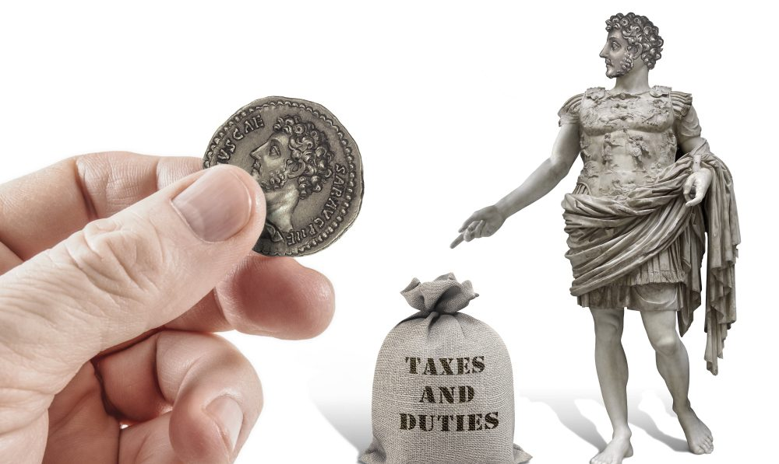
But Jesus, aware of their malice, said, “Why are you putting me to the test, you hypocrites? Show me the coin used for the tax.” And they brought him a denarius. Then he said to them, “Whose head is this, and whose title?” They answered, “The emperor’s.” Then he said to them, “Give therefore to the emperor the things that belong to him, and to God what belongs to God.”

REFLECTIONS:
Before being called by Christ to be one of his twelve Apostles, St Matthew was a tax collector operating in a customs house, somewhere in the north of Galilee. Since this profession required that he be able to read, write and especially keep records, these skills he would put to good use in writing his gospel account of Jesus’ mission. His literary style, as an evangelist, may be more artificial than that of St Luke, but there is no doubt that the gospel excerpt you have just heard is truly dramatic. The question put to Jesus, as to whether it was permissible for Jews to pay tribute to Caesar, gives a clear insight into the minds and strategy of the Pharisees. They were trying to walk Jesus into a political trap that would set him at odds with the Roman authorities, who were the rulers of Israel at that time, or, failing that, would discredit him before his own people. To avoid giving rise to suspicion of their intent, they decided not to get involved personally themselves. They sent some of their disciples along to Christ instead. It is quite likely that the leaders of the Pharisees stayed in the background because they wanted the followers of Herod, the Roman appointed tetrarch of Galilee, to take part also in the plot against Jesus, even though these Herodians, who openly advocated cooperation with the Romans, were normally their most bitter enemies.
The mock tributes to Jesus by this delegation, mention of his honesty, his fearlessness, his disregard for the status of those he encountered, all this flattery coming from people who normally were hostile to him merely highlights the hypocrisy of their praise. Then the trap was sprung: “Tell us what is your own opinion? Is it lawful to pay taxes to Caesar or not?” Were Christ to answer, “Pay the tax,” then he would stand accused of collaboration with the Roman oppressors, and would incur the scorn of ordinary Jews each of whom had to pay a poll tax, from the age of twelve for women and fourteen for men. Were he to advocate non-payment, he could be arrested for sedition by the Roman authorities. Jesus’ response, however, “Give to Caesar the things that are Caesar’s, and to God the things that are God’s,” left them confounded, and they slunk away. But Jesus’ reply left the matter in suspense, because it did not touch upon the right of the Romans to rule Israel, nor did it enumerate precisely the things o Caesar or those of God.
The opposing claims of God and state were left to be decided by the informed conscience of each individual, as they still are to this day. But there remains the warning of Jesus, in the Sermon on the Mount, that “no one can serve two masters; one cannot be the slave of both God and wealth” (Mt 6:24). Wealth in early Old Testament times was seen as created by God, and bestowed on patriarchs, kings and leaders who had roles of special responsibility. Later on, wealth ceased to be regarded as a gift from God. “Woe to those who join house to house and field to field, until everywhere belongs to them,” Isaiah warned (Is 5:8), and Jesus himself said, “alas for you who are rich; you are having your life of ease now” (Lk 6:24). The world and all its resources were created by God for the benefit of all human beings without exception, and this must usually obtain alongside the right to private property, whether inherited or acquired by personal enterprise. It is the task of government to seek balance between policies that will help the common good of all the citizens. And taxation is still one of the most common means of achieving this. Amen.
